**Lesson05 Explore Azure App Service**

**Notes: -**

**1-in Azure portal > App Service > Configuration**

**(in General Settings you see the language runtime configure)**

**(you can enable / disable web sockets in app service)**

**(you can enable / disable App Service when its idled out / which means not published by any users)**

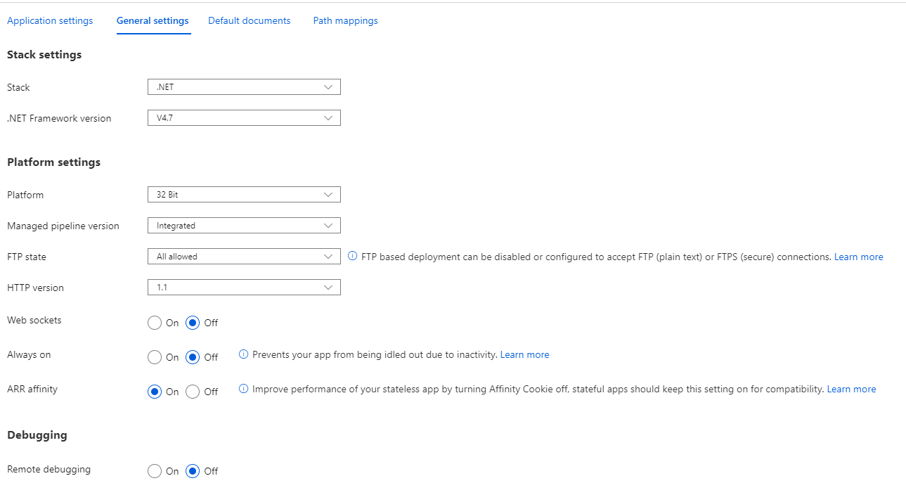

**(You can enable remote debugging and set the IDE 2017 / 2019)**



**2-In backups > you have to make sure that the app service plan is standard or higher**

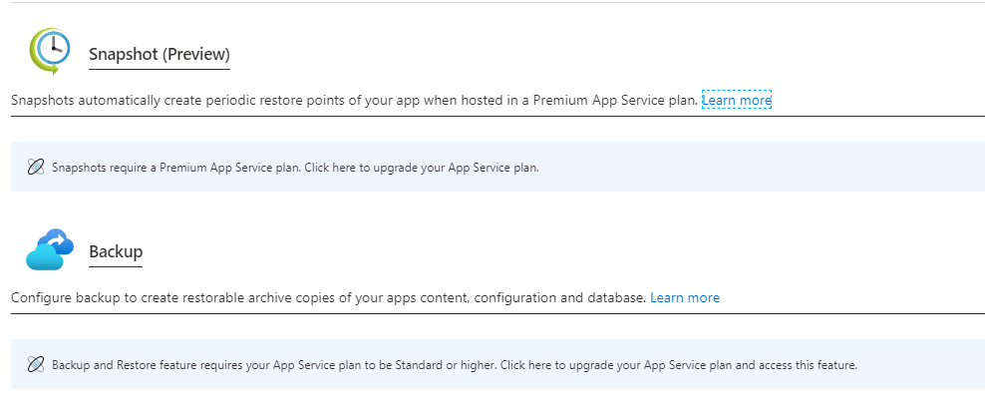

**3-in Azure App service > Authentication / Authorization**

**(you can see that you can enable the App service authentication by setting the Azure Active directory , Mircorosft , etc.)**

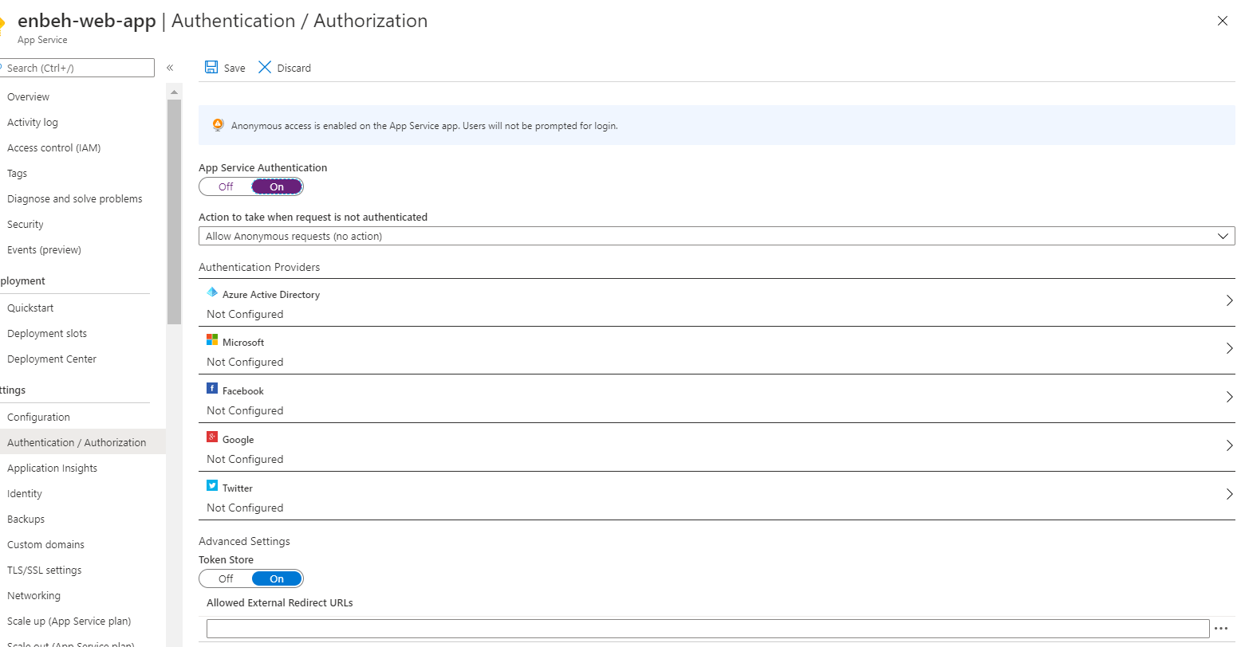

**4-on Azure App service > networking**

**(you can see the VNET that applied with azure app service)**

